To change layout and options in outlook 2013:

* Click the File tab

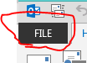

* Click Options

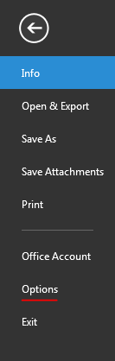

* How to change the top bar from white to a darker color.

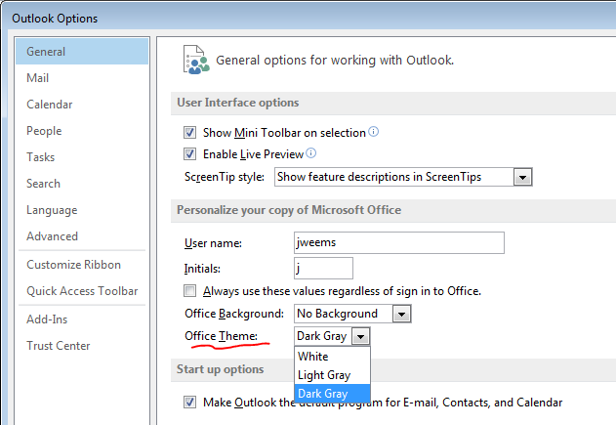

* How to choose a pattern for the top bar in outlook.

